(10 points) Cohort Exercise 2:

Design and implement a program that supports accepting two complex numbers from the user; adding, subtracting, multiplying, and/dividing them; and reporting each result to the user.

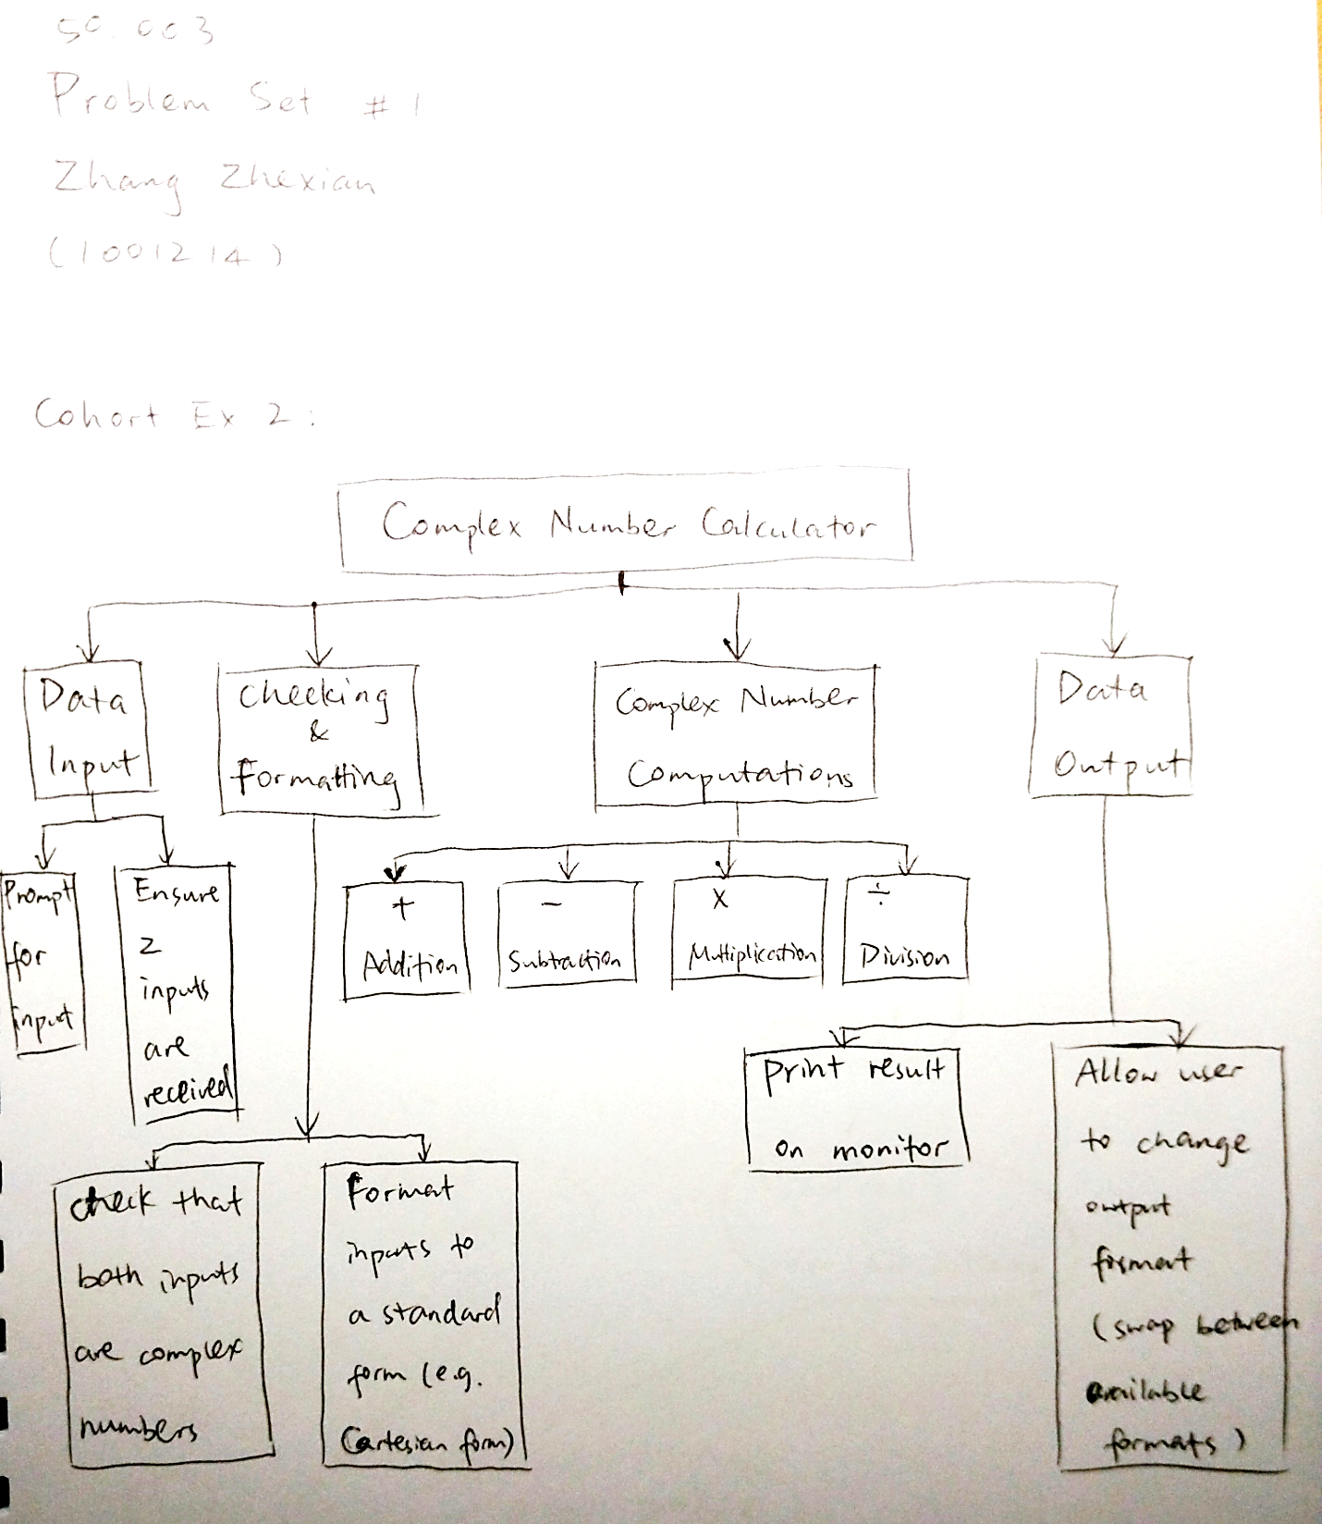

(10 points) Cohort Exercise 4:

Work as a group, document one use case of the App that you are developing.

|  |  |
| --- | --- |
| Name | Game ends |
| Objective | Conclude the current match of the game and show the users the results |
| Pre-conditions | Game has been running smoothly with both teams having all players in-game. |
| Post-conditions | Team A wins, Team B wins or Tie. Display Most Valuable Player (MVP). |
| Actors | Primary: Game system  Secondary: Player Notifier |
| Trigger | The timer reaches 00:00 |
| Normal flow | 1.   1. Game system stops all activities by disabling all buttons and movements of all players.  2.   2. Game system compares the timings of the two teams, also comparing the timing of how long each player holds the ball for  3.   3. Game system displays victory screen for the winning players, while displaying losing screen for the losing players. Also displays the MVP to all players’ screen. This is done through the Player Notifier.  4.   4. Game system displays two options – Rematch or Return to Main Menu. |
| Alternative flow | One or more player left the game before the screen displays the result, the game does not display the result to that player. |
| Interacts with | Ingame, Rematch, Return to Main Menu, Notify Player user cases |
| Open issues | Does the game end when one or more players leave in-game? |

(10 points) Cohort Exercise 5:

Draw individually a user case diagram for KBO.

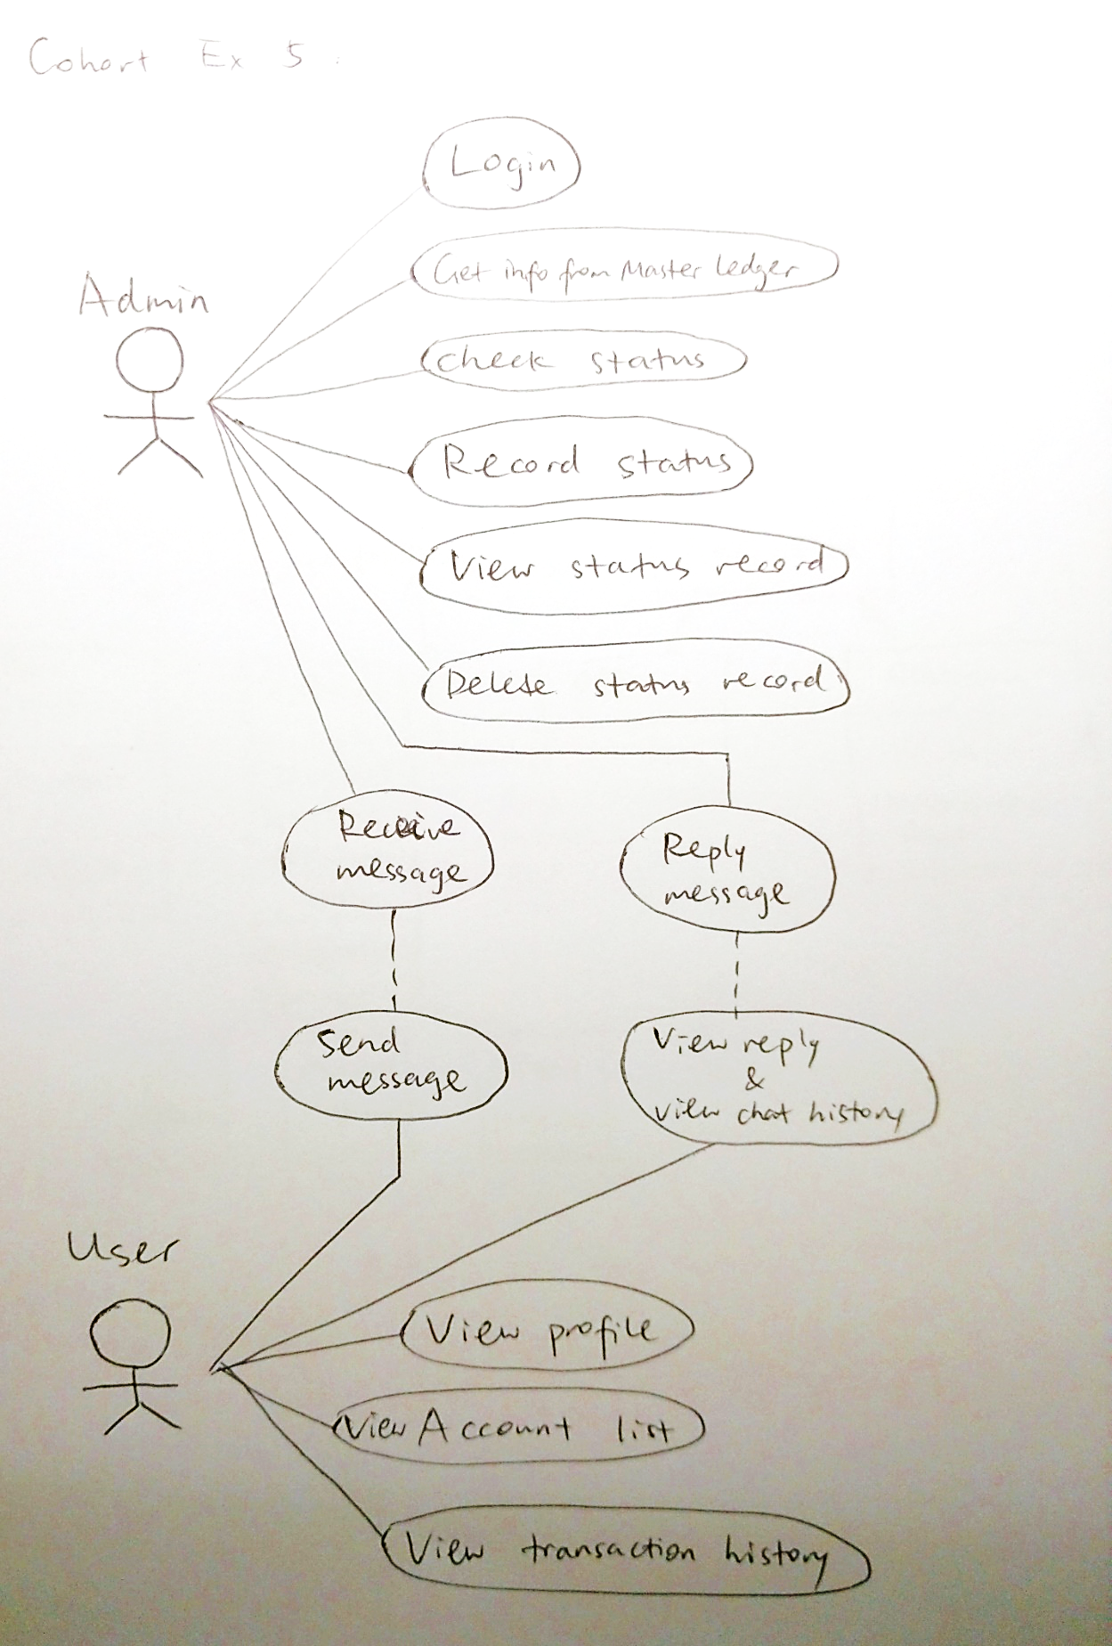

(10 points) Cohort Exercise 6:

Draw as a group a sequence diagram for one of your use cases.

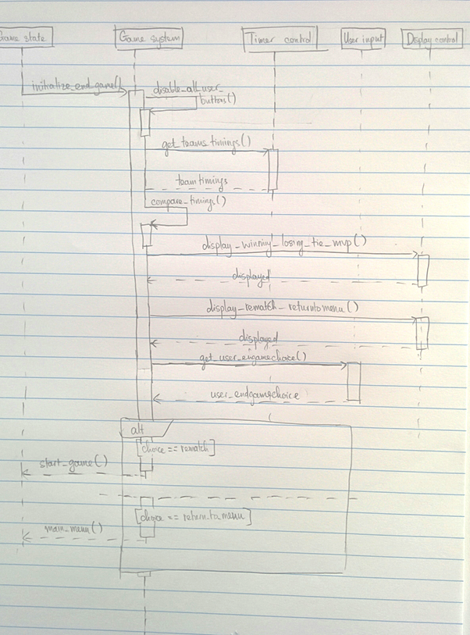

(10 points) Cohort Exercise 7:

Draw a class diagram for the following scenario. In a university there are different classrooms, offices and departments. A department has a name and it contains many offices. A person working at the university has a unique ID and can be a professor or an employee.

• A professor can be a full, associate or assistant professor and he/she is enrolled in one department.

• Offices and classrooms have a number ID, and a classroom has a number of seats.

• Every employee works in an office.

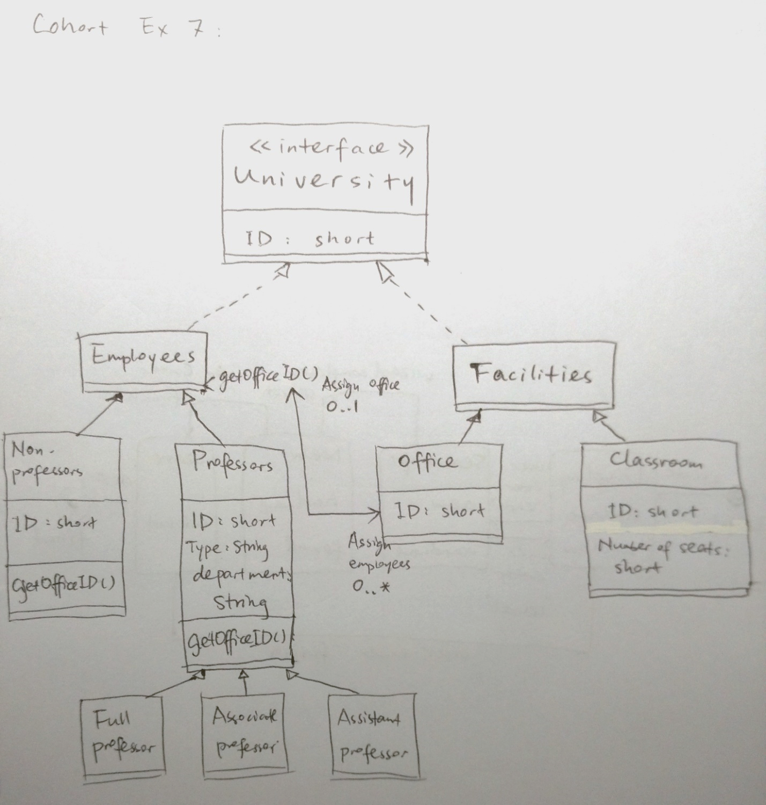

(10 points) Cohort Exercise 8:

A hardware update wizard can be in three states as follows:

1. Displaying a hardware update window.

2. Searching for new hardware.

3. Displaying new hardware found.

The wizard starts by displaying a hardware update window. While displaying this window, the user can press a "Search" button to cause the wizard to start searching for new hardware, or the user can press a "Finish" button to leave the wizard. While the wizard is searching for new hardware, the user may cancel the search at any time. If the user cancels the search, the wizard displays the hardware update window again. When the wizard has completed searching for new hardware, it displays the new

hardware found. Draw a state machine diagram that represents the function of the hardware update wizard just described.

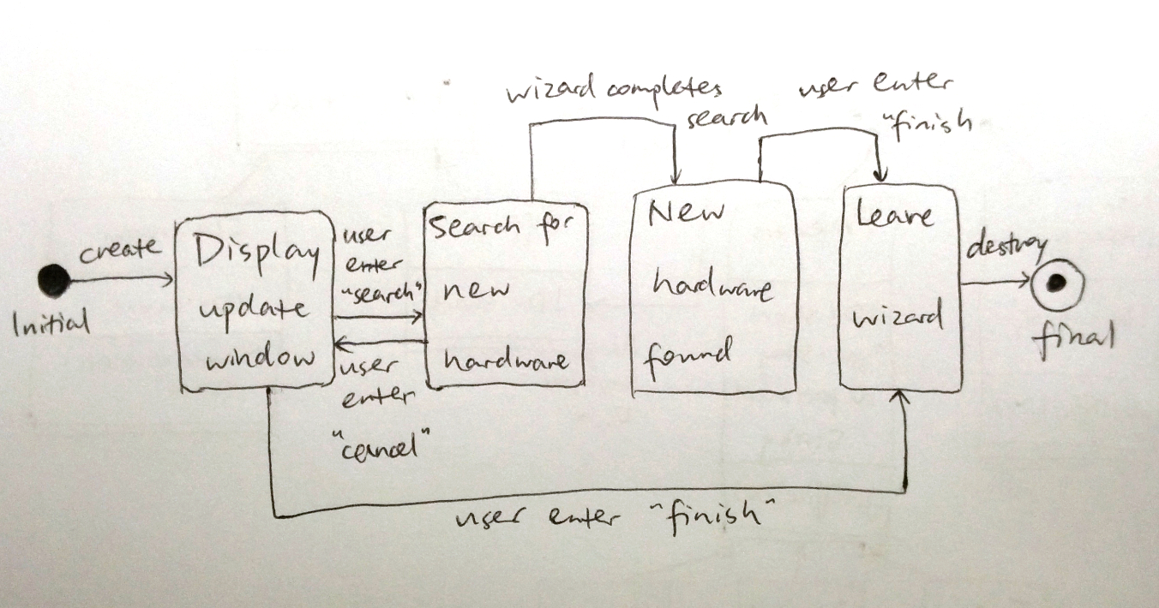

(40 points) Homework Question 1:

Work as a group, document five use cases of the App that you are developing. The use cases should be written following the recommended format (slide 49). Draw the corresponding sequence diagrams.

|  |  |
| --- | --- |
| Name | (Use Case #1) Pass ball |
| Objective | To pass the ball away from the ball-holding player |
| Pre-conditions | The ball-holding player must be currently holding the ball |
| Post-conditions | * Success   Ball has been passed out from the ball-holding player   * Failure   Ball is not being passed, the ball-holding player still possesses the ball |
| Actors | * Primary  1. Ball-holding player  * Secondary  1. Ball-holding player’s teammates 2. Ball-holding player’s opponents 3. The wall |
| Trigger | Ball passing signal (screen touch or button press) sent by ball-holding player |
| Normal flow | 1. Ball-holding player sent ball passing signal by screen touch or button press etc 2. The ball that the ball-holding player holds is passed away from the player, following the direction that the player is currently moving to, in a speed faster than the player’s travelling speed (same speed as other non-ball-holding players) |
| Alternative flow | * Ball hits the wall after being passed and bounces back * Ball hit another player right after being passed |
| Interacts with | Hijacking the ball, reach max holding time for the ball |
| Open issues | How to determine the direction of ball bouncing after it hits the wall? |

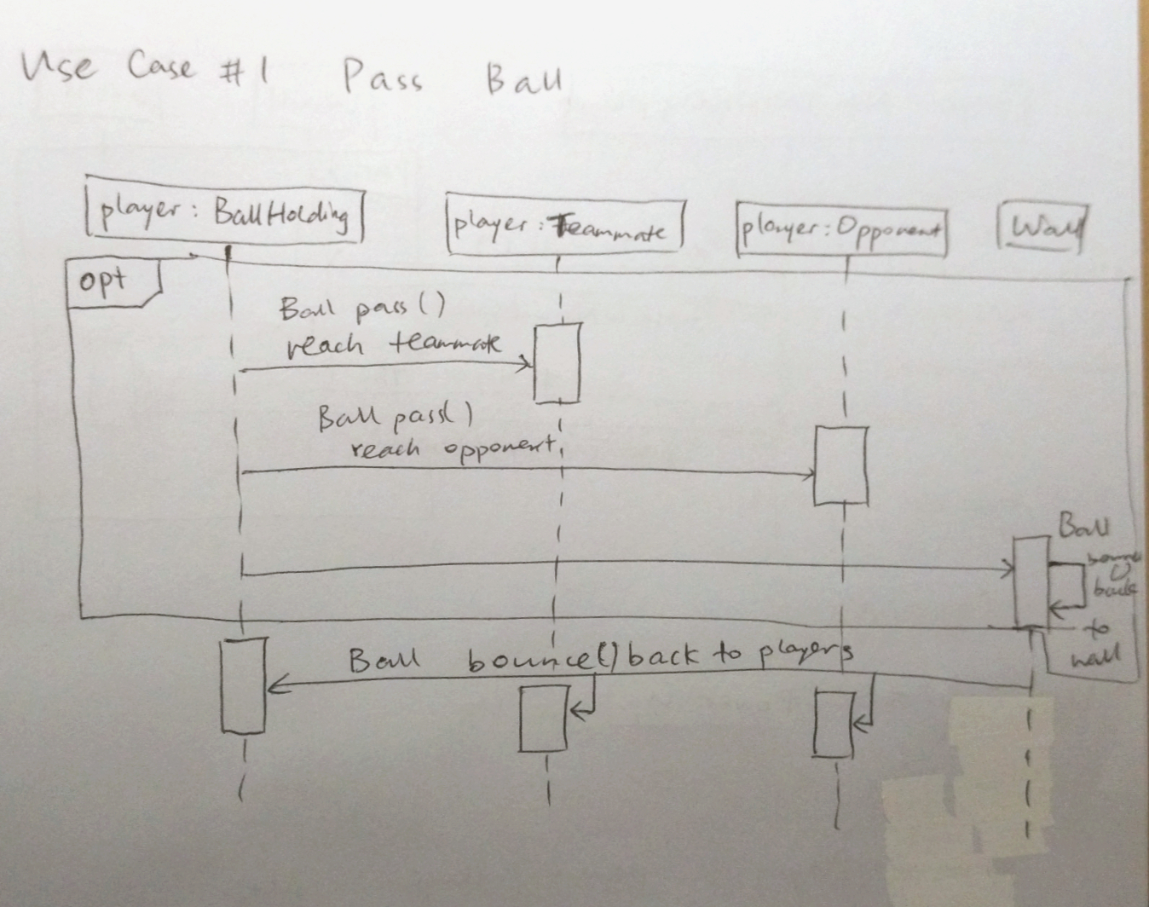

|  |  |
| --- | --- |
| Name | (Use Case #2) Dashing |
| Objective | A short dash towards the direction that the player is currently pointing towards |
| Pre-conditions | The player must not be in possession of the ball |
| Post-conditions | * Success   Player successfully moved quicker in a certain direction for a short distance   * Failure   Player did not manage to dash even after pressing the button  Player dashes for a longer distance than supposed to |
| Actors | All players in the game  The wall |
| Trigger | Button press/screen touch that sends a dash message from the players |
| Normal flow | 1.     The message for dash is received (pre-condition must be fulfilled)  2.     Player then dashes quickly (a speed faster than normal) towards the direction that he/she is facing for a short distance  3.     Player stops dashing and continues at normal speed |
| Alternative flow | * Player dashes towards another Player and stops dashing * Player dashes and steals the ball from another Player (player must stop dashing and go back to normal speed) * Player dashes towards the wall and stops |
| Interacts with | Hijacking the ball |
| Open issues | How fast and how long should the player dash? What happens when User holds the dash button instead of pressing it for an instance? |

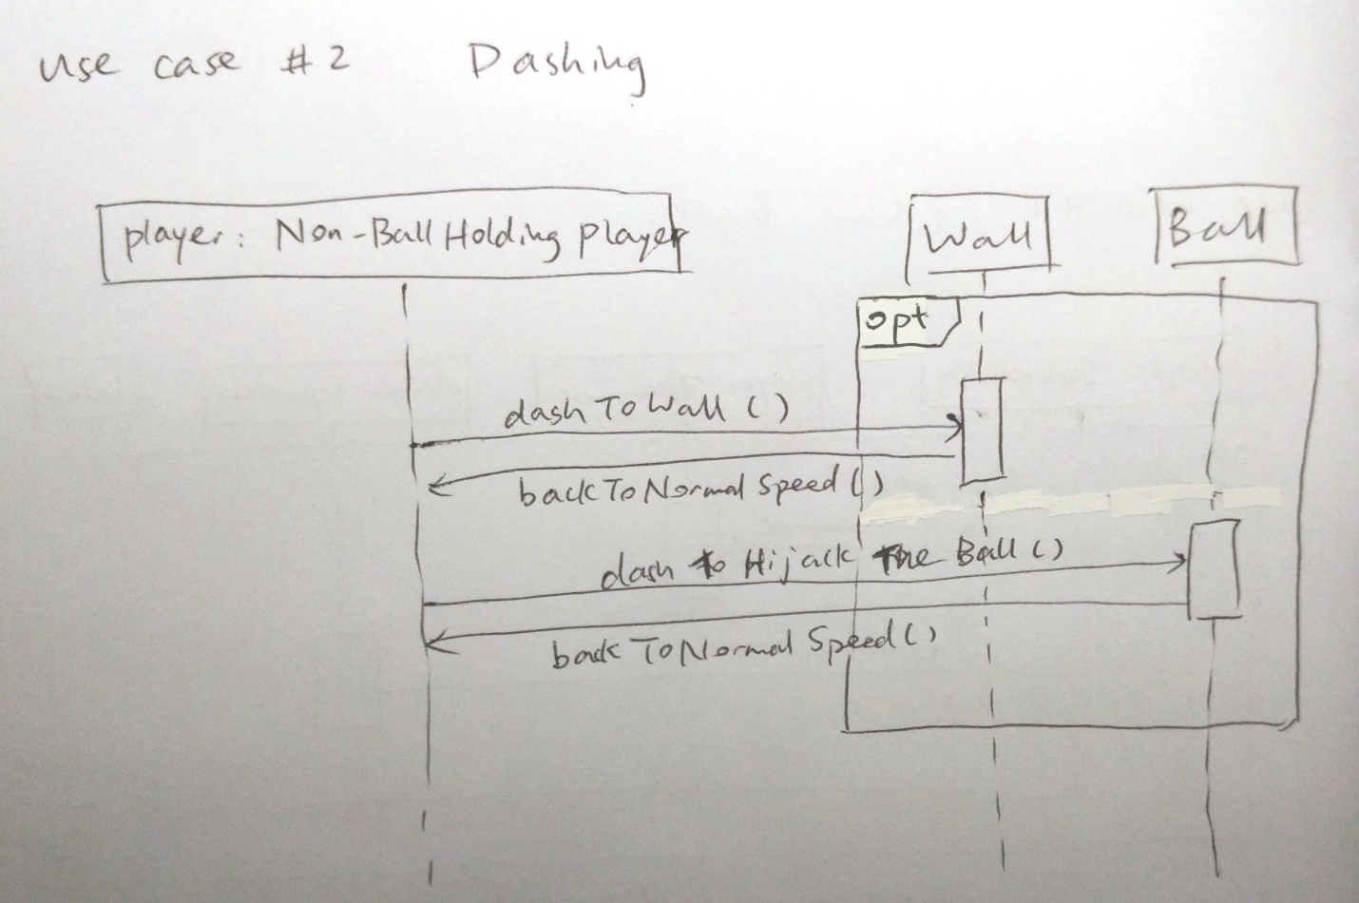

|  |  |
| --- | --- |
| Name | (Use Case #3) Acquire Power Up - freeze, oil spill, teleport, size augmentation, through wall |
| Objective | To fill up the power up slot of the player. Power up is a special action that can picked up and activated once to give him/her an edge over the opponent. Slot is freed after the use of the power up. |
| Pre-conditions | Game round has begun  User has an empty power up slot  Power up is available and can be acquired |
| Post-conditions | * Success   Player’s power up slot will be occupied  Power up package disappears from the map as it is acquired by the user   * Failure   Power up remains on the map after user acquires it |
| Actors | All players in the game  Power up packages |
| Trigger | Player comes into contact with the power up package |
| Normal flow | 1. Player comes into contact with the package 2. Package disappears from the map 3. Power up appears in the player’s power up slot 4. User’s power up button is ready and available for activation |
| Alternative flow | 1. Power up is randomly provided to each player at the beginning of the round |
| Interacts with | Spawning of Map objects, Player power up slot(s) |
| Open issues | Can the power up within the slot be replaced with a new power up? Is the power up a one use or multiple use instance? Can the player posses multiple power ups? |

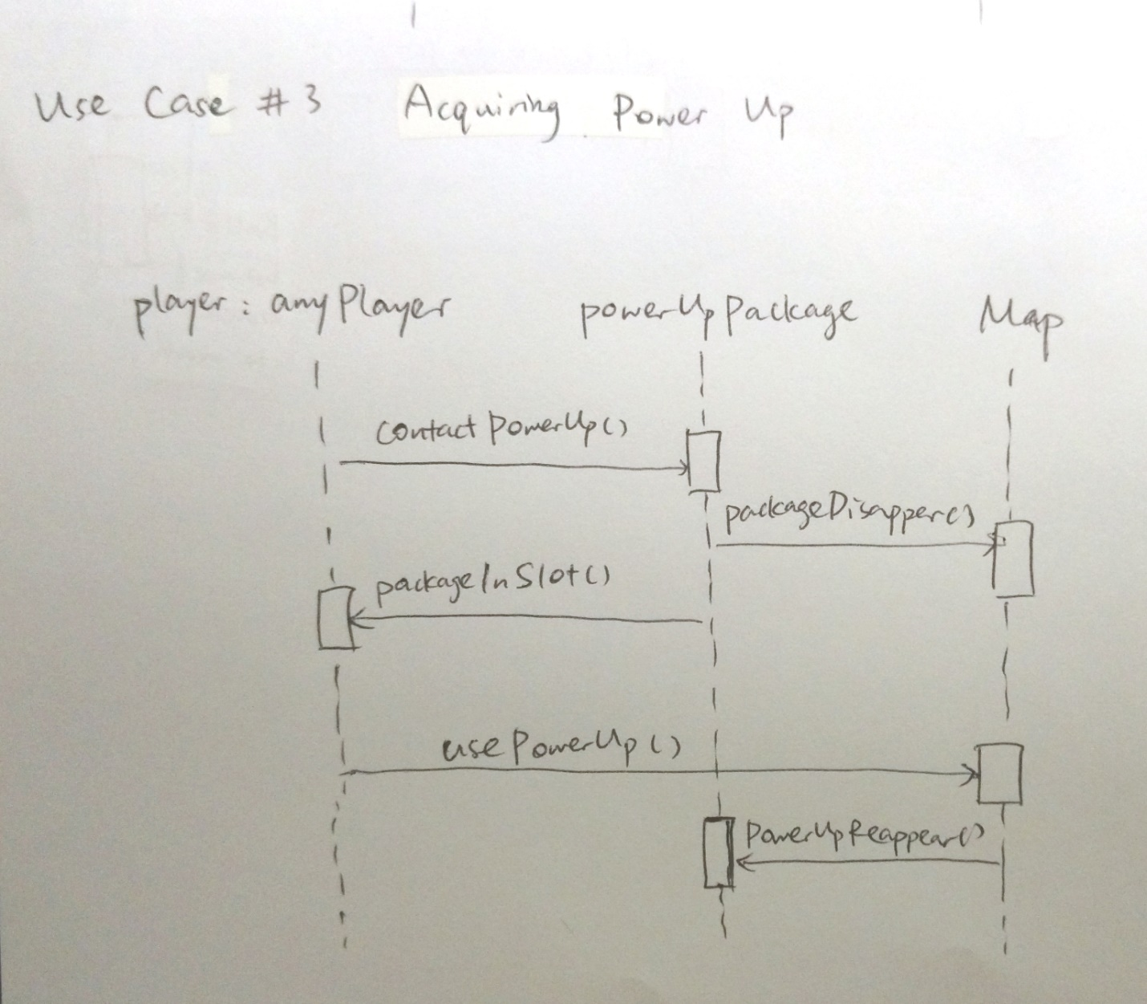

|  |  |
| --- | --- |
| Name | (Use Case #4) Intercept ball |
| Objective | An automatic action that allows a user to acquire the ball from another user upon collision/contact |
| Pre-conditions | A player must be in possession of the ball  Collision between a player with the ball, and another player without the ball |
| Post-conditions | * Success   Ball possession shifts from one player to the other   * Failure   Ball possession does not change |
| Actors | All players in the game |
| Trigger | Contact between two players, one of which is holding the ball |
| Normal flow | 1. A player is in possession of the ball 2. Another player comes into contact with him/her 3. Ball possession shifts from one to the other |
| Alternative flow | 1. Multiple players come into contact with the player with the ball 2. Ball interception will fail, and will be dropped in a random direction near by 3. Ball is in a free for all state |
| Interacts with | Map objects, Player |
| Open issues | Would the trigger lead to an infinite loop when the two players remains in contact with each other? Would a collision refer to players having a model boundary contact or an overlap of the model? Can an intercept be prevented? |

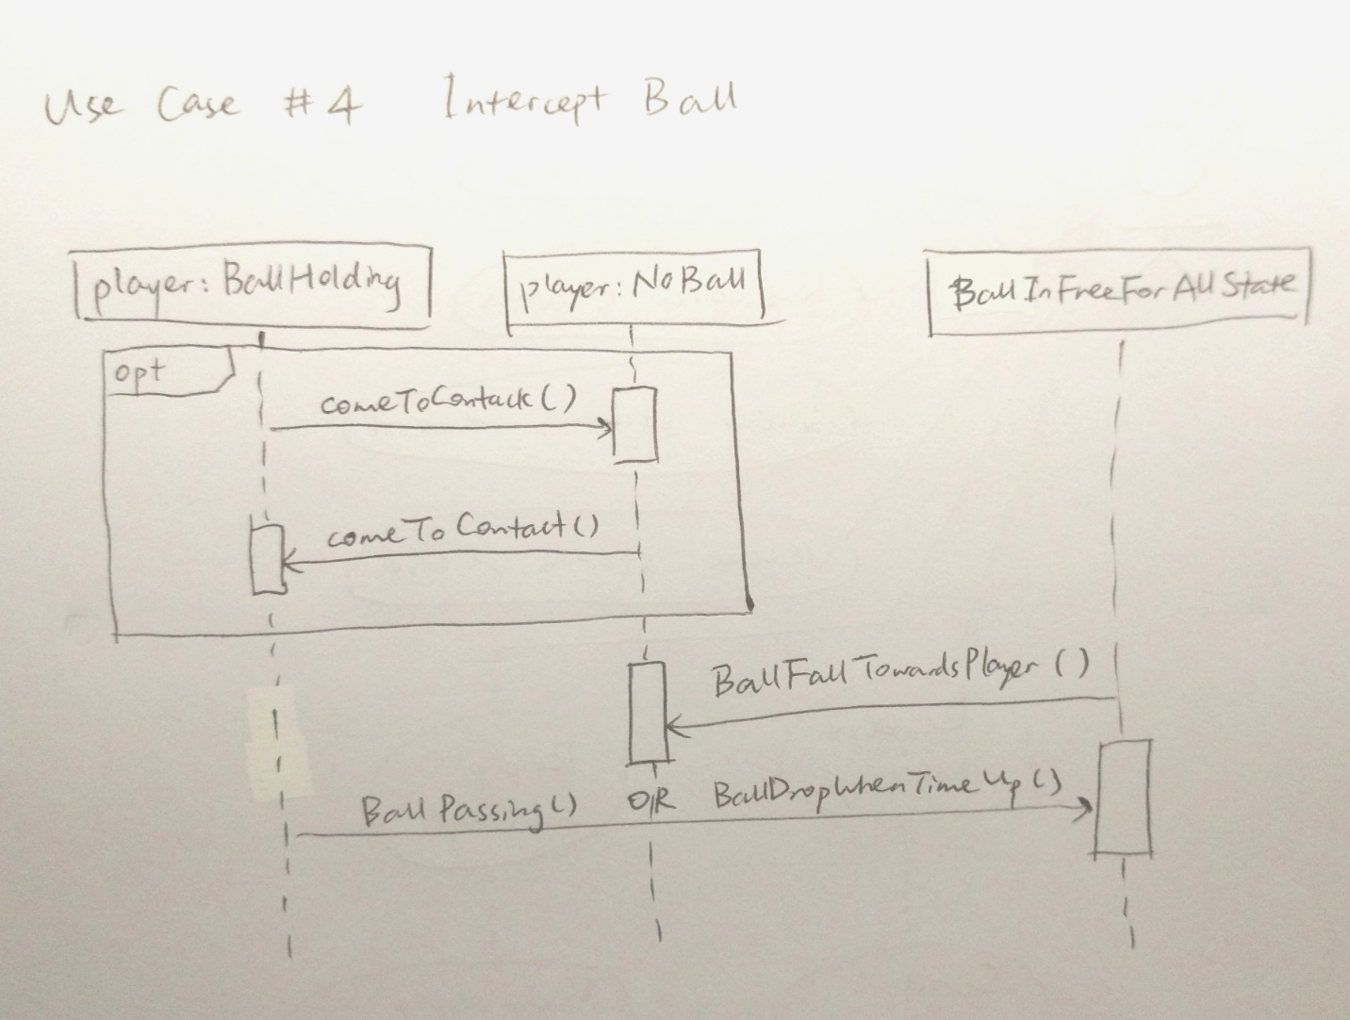

|  |  |
| --- | --- |
| Name | (Use Case #5) Timer for the ball |
| Objective | Timer starts when ball is in possession, and player must lose possession of the ball if time runs out |
| Pre-conditions | The player must be holding on to the ball, and must have held it for a certain amount of time already |
| Post-conditions | * Success   Ball is thrown out of the player’s hand when time is up  Timer stops when Player passes the ball and starts whenever any Player holds the ball   * Failure   Timer does not start when Player has the ball  Player is still in possession of the ball after time is up  Player passes the ball before time is up |
| Actors | * Primary   1. Ball-holding player   * Secondary   1.     Ball-holding player’s teammates  2.     Ball-holding player’s opponents  3. The wall |
| Trigger | When the player exceeds the time that they can hold onto the ball |
| Normal flow | 1.     Whenever any player gets a hold on the ball, timer starts  2.     Player is still holding on to the ball and time runs out  3.     Ball should automatically be thrown out of Player’s hands at a speed faster than the ball-holding Player towards the direction that the Player was facing  4.   Timer destroyed when no one is in possession of the ball  5.   Timer starts again when any Player takes the ball |
| Alternative flow | * When power ups are used to extend the timer |
| Interacts with | Passing the ball |
| Open issues | How far should the ball be thrown to? How long should the timer be? |

